Trekking Management System

1. Student Details
Name: Aman Sachin Kujur

Roll Number: 23F3002457

Email: 23f3002457@ds.study.iitm.ac.in

About Me:

I am a BS Degree student at IIT Madras pursuing Data Science and Applications. I have a strong interest in software development, machine learning, and building scalable web applications using modern frameworks.

2. Project Details

Project Title: Trekking Management Application

Problem Statement:

Develop a role-based web application for managing trekking activities where Admins, Trek Staff, and Users interact through a secure system supporting trek management, booking, background jobs, caching, and reporting.

Approach:
The application follows a client-server architecture with Vue.js as the frontend and Flask as the backend. JWT authentication is used for role-based access, SQLite stores application data, Celery handles asynchronous tasks, Redis is used for caching and background task brokering, and Flask-Mail sends automated emails.

3. AI/LLM Declaration
AI assistance (ChatGPT - GPT-5) was used throughout the project for Bootstrap/basic UI, understanding concepts, debugging errors, generating documentation, and reviewing implementation.
The overall AI usage is estimated to be approximately 8-15%. All implementation decisions, integration, testing, debugging, and final verification were performed manually by me, and I understand the submitted code and architecture.

4. Technologies and Frameworks Used
Technology | Purpose
Flask | Backend REST API
Vue.js | Frontend user interface
Bootstrap | Responsive UI styling
SQLite | Database
SQLAlchemy | ORM for database operations
Flask-JWT-Extended | Authentication and authorization
Flask-Mail | Email notifications
Celery | Background task processing
Redis | Celery broker and caching
Flask-Caching | Redis-based API caching

5. Database Schema / ER Diagram
The application uses three primary database tables.
User
Stores information for all users, including Admins, Trek Staff, and Trekkers. Role-based access is managed using the role field. The table also stores authentication details and account status.
Trek
Stores trek details such as trek name, location, difficulty, duration, available slots, assigned staff member, status, start date, end date, and description.
Bookings
Stores booking records created by users. Each booking links a user to a trek and stores the booking date, booking status, and payment status.
Relationships
- One User → Many Bookings
- One Trek → Many Bookings
- One User (Staff) → Many Assigned Treks
The schema uses foreign key relationships to maintain referential integrity while reducing data redundancy.
ER Diagram:
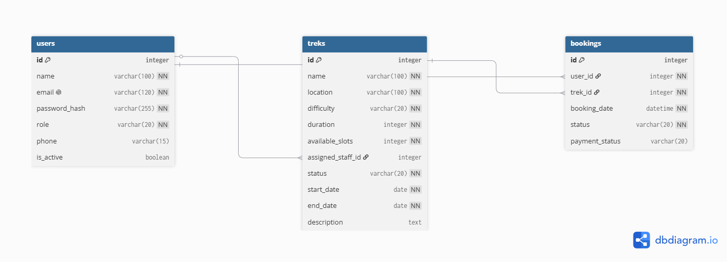

6. API Resource Endpoints
Endpoint |  |  |  | Method | Description
/register |  |  |  | POST | Register a new user account
/login |  |  |  | POST | Authenticate user and generate JWT token
/profile |  |  |  | GET, PUT | View and update logged-in user's profile
/treks |  |  |  | GET, POST | View all treks or create a new trek (Admin)
/treks/<id> |  |  |  | GET, PUT, DELETE | Retrieve, update or delete a trek
/bookings |  |  |  | GET, POST | View booking history or book a trek
/bookings/export |  |  |  | POST | Export booking history asynchronously as CSV
/staff |  |  |  | GET, POST | Manage trek staff (Admin)
/staff/treks |  |  |  | GET | View treks assigned to logged-in staff
/admin/users |  |  |  | GET | View all registered users
/admin/statistics |  |  |  | GET | Retrieve dashboard statistics for Admin

7. Architecture and Features (optional)

Architecture Overview
- Vue.js – Frontend Single Page Application (SPA) for Admin, Staff, and User interfaces.
- Vue Router – Handles client-side navigation between application pages.
- Flask – Backend REST API handling authentication, trek management, bookings, and user management.
- SQLAlchemy – ORM used to interact with the SQLite database.
- SQLite – Stores application data including users, treks, and bookings.
- Flask-JWT-Extended – Provides JWT-based authentication and role-based authorization.
- Celery – Executes asynchronous background jobs such as reminder emails, monthly reports, and CSV exports.
- Redis – Used as the Celery message broker and backend for Flask-Caching.
- Flask-Mail – Sends automated emails to users and administrators.

Implemented Features
- User registration and login
- JWT-based authentication and role-based access control
- Admin management of treks, staff, users, and bookings
- Staff management of assigned treks and participant lists
- User trek booking, cancellation, profile management, and booking history
- Search and filtering of available treks
- Daily reminder emails using Celery
- Monthly HTML activity report emailed to the Admin
- Asynchronous booking history export as CSV
- Redis caching for frequently accessed trek data
- Prevention of duplicate bookings and overbooking
- Booking allowed only for treks with Open status
- Complete trekking history maintained for every user
- Email notifications using Flask-Mail
- Redis-based API caching with automatic cache invalidation
- Dashboard statistics for the Admin
- Basic Responsive user interface built using Bootstrap
Additional Features:
NONE

8. Video Presentation
DriveLink:
https://drive.google.com/file/d/1c20egtF7QQG2Mc1XkVJMLW5BX4Xmy9Ah/view?usp=sharing

